W209 – Simon Macarthur

**Customer Satisfaction: Credit Cards**

There has been much debate over the decision to maintain the student credit card line, or to discard it due to lower profits. A customer survey was provisioned with 300 responses for each card type being collated and analysed to provide insight into the member responses for satisfaction and its subsequent impact upon this important decision.

As can be seen in the table, there is a larger market share for the Student Card (30%) followed by Basic (20%) and Travel (10%). Given the fact that the

Student and Basic cards are provided without charge, the increased market

share is not surprising. However, it can also be seen that the average age

of the card holder also increases with the card type. Thus, as a customer is moving through life stages, if we are able to obtain them as a customer on the student travel card, we will ultimately turn some of them into profitable customers. Without this pipeline available, we would be required to obtain new customers from market acquisitions, which contain a significantly higher cost per acquisition.

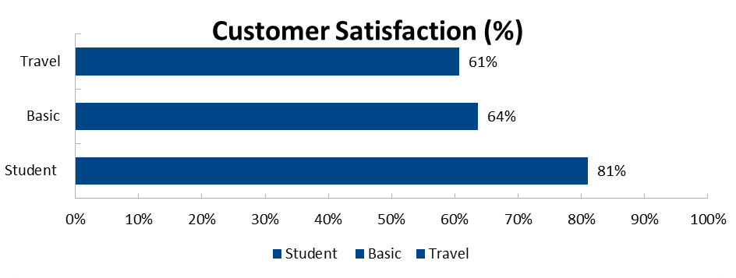

Overall, when reviewing the output of the satisfaction survey, there was no real difference in the level of satisfaction for the Basic and Travel cards, with both having an average satisfaction of approximately 60%. However, in contrast, the Student card has a much higher average satisfaction rating of 81%. This is shown from the survey with a statistically significant difference in satisfaction levels between cards. This again shows that, putting profitability aside, customers are very satisfied with the student card and are likely to progress to other products.

Various studies performed over the years, starting with one conducted by Xerox Corp. in the early ‘90’s, have consistently shown that a Totally Satisfied customer is, on average, from 3-10 times more likely to buy from you again than a customer who is merely Somewhat Satisfied.

|  |
| --- |
| ***A Totally Satisfied Customer contributes 2.6 times as much revenue to a company as a Somewhat Satisfied Customer.***  ***A Totally Satisfied Customer contributes 14 times as much revenue as a Somewhat Dissatisfied Customer.***  ***A Totally Dissatisfied Customer decreases revenue 1.8 times what a Totally Satisfied Customer contributes to a business.*** |

Additional studies conducted by the developers of InfoQuest have taken those findings a step further. Not only is the propensity to buy much greater among Totally Satisfied customers, but we have been able to statistically verify that the implied financial relationship between customer satisfaction and revenues is also measurable and predictable.

Thus, when reviewing the output of the customer satisfaction survey, the high levels of satisfaction within the student card need to be reviewed to identify the main drivers of this. This currently will be allowing customers to transition off this card, and onto other products. However, as the level of satisfaction drops significantly once moving to the other products, it is less likely that the customer will be satisfied with the product. This, in turn, will result in a less profitable customer and ultimately define their decision as to whether to purchase additional products.